

MARANDA 2025 KCSE PREDICTION
EXPECTED EXAM 1
ELECTRICITY
448/2
PAPER 2 (Practical)
TIME: 2½ HOURS

NAME……………………………………………………………………………………..
SCHOOL……………………………………………… SIGN………………………..
INDEX NO……………………………………………. ADM NO……………………

Kenya Certificate of Secondary Education.

INSTRUCTIONS TO CANDIDATES
- Write your Name, Class and Index Number in spaces provided
- There are five exercises in this examination
- Candidates are allowed 30 minutes for each exercise
- Each exercise will be awarded a maximum of 20 marks
- At each station, candidates are not allowed to either view the previous station’s work or read instructions for the other stations
- Attempt all the four exercises
- All dimensions are in millimeters unless otherwise stated
- Candidates should answer the questions in English
For examiner’s Use only
EXERCISE | 1 | 2 | 3 | 4 | TOTAL
MARKS(EC)
MARKS(MC)
GRAND TOTAL

EXERCISE 1
Using the materials, equipment and measuring instruments provided, perform the following tasks
- Connect the circuit as shown in Figure 1 (2$\frac{1}{2}$ marks)
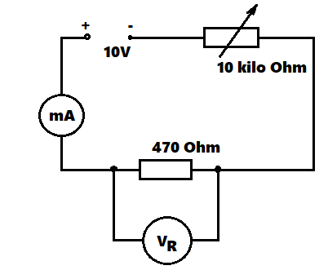
Figure 1.
- Connect the circuit to the power supply (1 marks)
- Turn the power on and adjust the potentiometer to obtain each of the voltages (V_{R}) shown in Table 1.in each case read and record the corresponding current I. (6 marks)
V_{R} (Volts) | I(mA) | Power (mW)
3
4
5
6
7
8

- For each value of VR, calculate the power dissipated in the 470Ω resistor and complete the table (5 marks)
- Using the values in Table 1 draw the graph of power against voltage V_{R}. (5$\frac{1}{2}$ marks)

EXERCISE 2
Using tools equipment and materials provided make the space bar saddle as shown in Figure 2
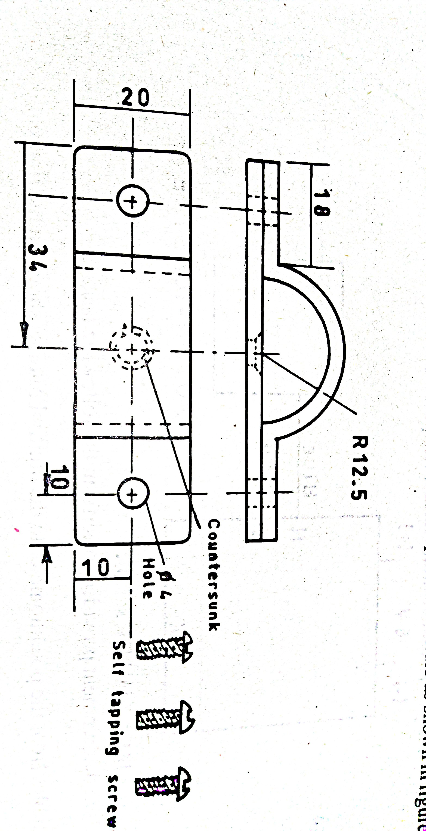
EXERCISE 3
- Connect circuit as shown in figure 3. Let examiner check your work ($2$marks)
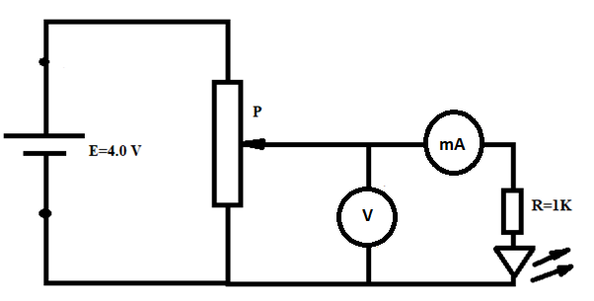
Figure 3
- Adjust the potentiometer and complete the table below (6 marks)
V(v) | 0 | 0.5 | 1.0 | 1.5 | 2.0 | 2.5 | 3.0 | 3.5
I(mA)

- Adjust the potentiometer until LED starts to glow. Record voltage___________ (1 mark)
- Plot graph of I(mA) against V(v) (10 marks)

EXERCISE 4
Figure 4 shows a layout of a power final sub circuit. Using PVC conduit wiring system, install the circuit
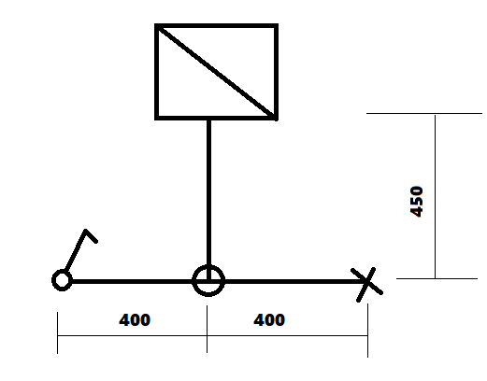
Figure 4

